Jack Berberian

CIS 245

2/26/22

Continue Setup – CentOS Stream 9

Some things to know beforehand:

* By adding -y to a command at the end, you can skip prompts that ask you to confirm whether you’d like to do something like installing a program, removing a program, or upgrading something.
* Sudo is needed for commands that need administrative privileges such as installing a program, and changing system settings to name a few.
* DNF and Yum are two default package managers (software storage places) for Cent OS.

1. How to install Tmux

* Command to enter: sudo dnf install tmux -y

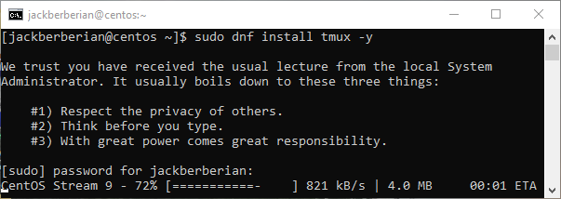

1. How to install emacs

Since emacs isn’t included the with a standard installation of Cent OS, you have to download special packages meant for enterprise users and then install it.

* First command: sudo dnf install epel-release -y

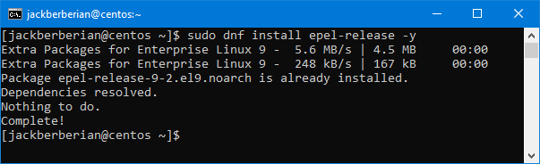

* Second Command: sudo dnf install emacs -y

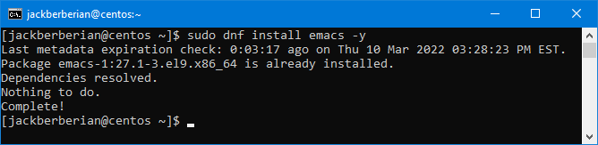

1. How to install Fail2Ban

* Enter: sudo dnf install fail2ban

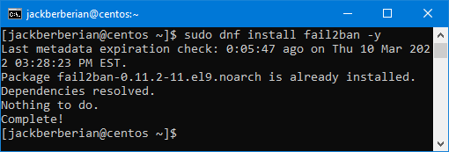

1. How to install cowsay

https://centos.pkgs.org/8/epel-aarch64/cowsay-3.04-16.el8.noarch.rpm.html

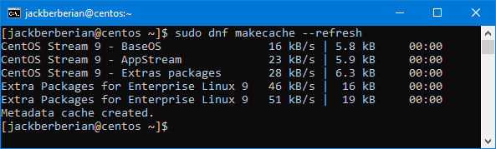

1. How to install lolcat

https://snapcraft.io/install/lolcat-c/centos

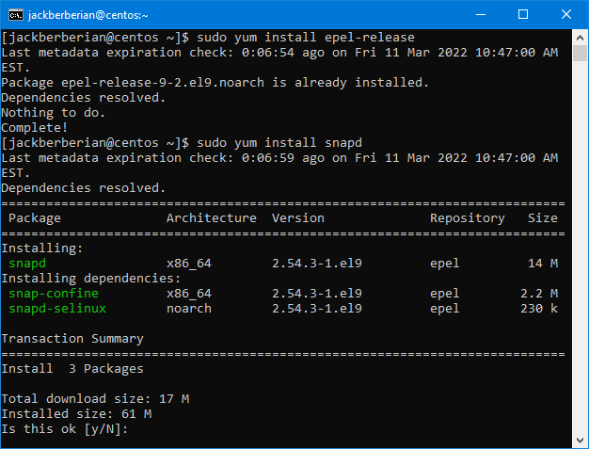

1. How to update VI to vim

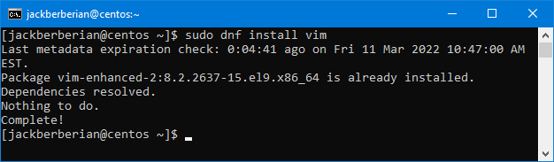

1. How to update your servers if needed

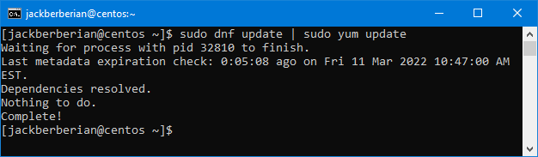

1. Repo List

